**OOP project report**

**Examination System**

Examination system works in two steps

1. A teacher logins first to set the time when the quiz should happen
2. A students logins to attempt the quiz
3. Teacher:

The code has a csv file which it reads and generates the ids when the teacher logins with right name and password then the program shows what func to perform.

Firstly the teacher will login by adding the right credentials and then after finding the correct id the program will lead the teacher to his dashboard.

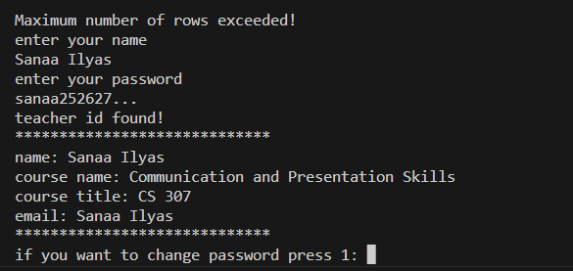

After the the task to perform will be displayed.



Then the teacher will select the right option:

If you select 2 you will select the time first and the then the program will ask you to set the question paper and vise versa

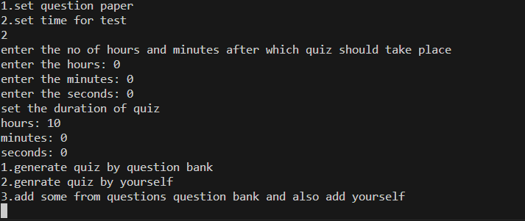

Setting the quiz gives you 3 options and then the teacher will select the right option and then the teacher will set the number of question, total marks and marks for every question.

After that the countdown for the quiz will start. When its time for the quiz the students an come login and start the quiz.

1. Student:

The student will first login with the name and nu id as password

After login we will display the dashboard of the student that in what courses he is enrolled and the program will show whether or not the student can give that quiz. The student will be able to attempt the quiz only when he was enrolled for the course.

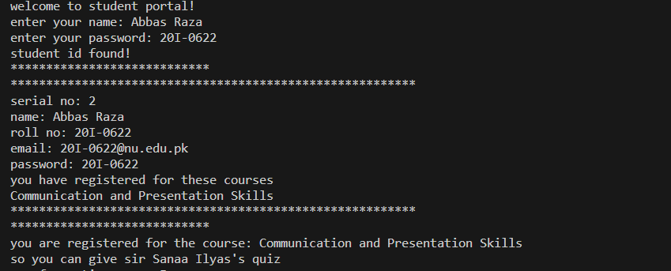

After than the code displays the question paper

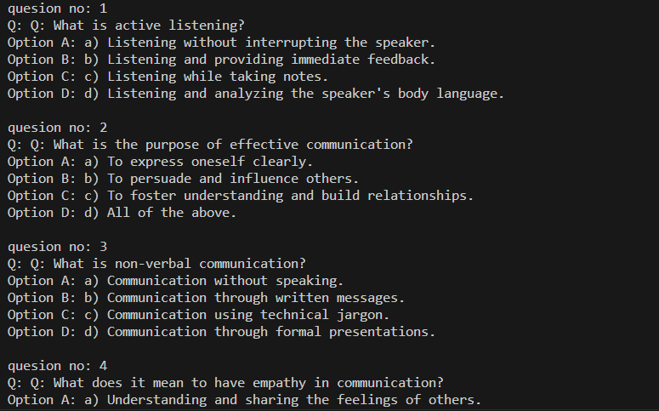

After that the time for the quiz starts and students select right options after that their answers along with right key is displayed and they are given the marks they obtained.

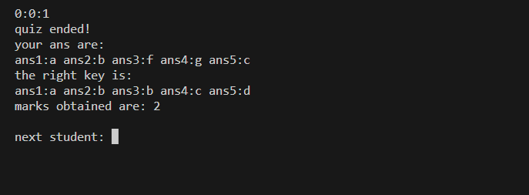

When the quiz of one student ends the program will give you an option of another student or else it will terminate.

Login

|

|

______________________

| |

Student teacher

**(inheritance)**

Where login is parent class and student and teacher are child classes

**(composition)** is used between student and course registration where a variable of corse registration is created in student class

**(inheritance)---🡪(multiple inheritance)** quiz class inherited q_bank and time class just to use the func present in both class. Or in other sence the quiz should have an acess to q_bank to show the q and an acess to time to display the time of the quiz.

**(composition)** composition is present between teacher and q bank here we have has a relation that says that teacher has a q bank.

